Epro Implementation Methodology
21 Oct 2013

Contents
Contents 2
Epro implementation methodology 1
Introduction 1
Overview 1
Epro implementation stages 1
Timescales 3
Accountability 4
Project sponsors – executive responsibility 4
Project implementation manager – operational responsibility 4
Project managers 4
Project team roles 4
Epro team roles 4
Trust team roles 5
Responsibilities and actions of team roles 5
The Epro Roadmap project tool 8
Significant customised software development 12
Project stages 12
Stage 1 - Kickoff 12
Stage 2 - Preparation 13
Stage 3 - Epro Transcriber Bootcamp 13
Stage 4 – Pre-pilot 14
Stage 5 – Epro Author Bootcamp 14
Stage 6 - Pilot 15
Stage 7 - Roll out 15
Stage Sign off 16
Background 16
Terms 16

Epro implementation methodology

Introduction
The purpose of this document is to describe a structured and comprehensive methodology which will underpin the successful implementation of the Epro Clinical Workflow Solution.
Where the implementation of Epro is being led by a trust project board, with a nominated project manager, it is intended that the stages, work packages and tasks described within this document, are the minimum to be included within the overall trust project plan.
This plan will also address the tasks associated with local project governance, policies and procedures.

Overview
The Epro implementation methodology is focused on the development of a good working relationship between the Epro implementation team and the trust implementation team, with good communication between all participants. The methodology promotes the following project principles:
- The timely and regular sign off of small sections (stages) of the project prior to moving to the next element
- Regular and efficient sharing of information between team members and the project board, focused on regular highlight reports and the early identification of project issues and risks
- An environment which ensures that there is sufficient contact time between the two teams to allow for both structured and unstructured knowledge transfer
- The early implementation of a closely supervised pilot project, in one to three discrete areas, to establish a baseline for subsequent implementations,
- The opportunity to learn from the experience of the pilot before wider roll out
- A second phase of implementation, focused on the wider roll out of the system across the trust as part of a rapid roll out. This phase is managed by the trust.
The implementation methodology is divided into seven stages of implementation and hinges around three key events – the Epro engagement day and the two Epro implementation bootcamps. Each stage is further divided into a number of work packages with one or more associated tasks. The methodology is underpinned by the use of a web-based Epro Roadmap project tool (http://roadmap.epro.com), which provides visibility of the status of the project in an easy graphical form, maintenance of risk, issue and communication logs together with an integrated timeline and weekly highlight reports.

Epro implementation stages
The following table illustrates the key Epro implementation stages:
1 – Kickoff | This is the initial kick off stage for the project and is an opportunity for the two project leads to build relationships and to commence planning for the Epro discovery day. It also includes a number of steps towards preparation for implementation such as a technical planning call, distribution of resources, building of hardware and preparation for building the demographic interfaces.  The Epro Engagement Day is an onsite day designed to support the change management process by allowing wider interaction with the software and also to begin the process of dissemination of knowledge to the trust implementation team.
2 – Preparation | This stage allows the project teams to develop the necessary PAS HL7/interface setup, change management and other pre-requisites prior to the Epro Transcriber Bootcamp.
3 – Epro transcriber bootcamp | During this stage the Epro team will come onsite and work jointly with the trust team in the configuration and limited go live of Epro for transcription.  The bootcamp will include a “mini pilot” which is internal to the project team and intended as a test environment for them to develop and practise the work flow and training.  On completion of this stage there will be representative transcribers from the pilot departments who are live in the transcription process. The trust team are fully involved in the setup and testing of the solution and thus have the opportunity to acquire a high level of knowledge of the solution.
4 – Pre-pilot | This is a bedding in period after the transcriber go live to allow consolidation and preparation for the Epro Author Bootcamp.
5 – Epro author bootcamp | This repeats the processes of the previous bootcamp to extend across the whole letter production process. At the end of this stage there will be representatives of the pilot departments live across the whole letter production process.
6 – The pilot | This stage is an opportunity to extend use across the pilot department(s) and evaluate and review the pilot implementations. There may be further development of the best possible “To be” process in support of the on-going use of the system in other areas, prior to developing a roll out package to support rapid roll out in Stage 6.  It is also a chance for the trust to gain a deeper understanding of the solution, to design reporting requirements and to start preparation for ensuring the full benefits of the system are realized.
7 - The roll out | Following adoption of the lessons learned from the pilot stage, the subsequent roll out of the system across other areas is managed by the trust by further implementation and training in the package. This is essentially a process of bringing successive departments on stream one by one. Most of the activity is delivered by trainers / floorwalkers.

Timescales
The project kick-off meeting usually happens within two weeks of signing the contract and we will propose the provisional timescales for pilot implementation and roll out. These will be subject to confirmation by the trust, particularly in respect of the availability of its human technical resources. In considering the timescales, it is essential that there is full commitment to the necessary resource from the trust, and in particular of the key technical resource for the development of the hl7 messages and data extracts.
If there is availability of staff on both sides, the Epro Engagement Day can occur within two weeks of the kick-off meeting, followed by the Epro Author Bootcamp approximately 4 - 6 weeks later. However, this assumes both availability of staff and that there is no significant new development required.
Once dates are agreed, the preparation period between the Epro discovery day and the Epro implementation bootcamp should be regarded as relatively fixed. This is designed to be a short period of intense activity and changing the bootcamp dates risks introducing scope creep and increasing demands on project management resources rescheduling resources.
If the trust identifies additional tasks or custom development, which are critical to the project go live date e.g. an interface to an external system, it is important that these are identified early in the project. Tasks of this nature should be identified early in the kickoff stage, so that the work can be scheduled and accommodated within reasonable implementation timescales. With regard to custom development, it is commonly found that the need for this alters during the pilot period as the trust gain a greater understanding of the solution.
The length of the pilot stage is typically between one and three months depending on the preferences of the trust, availability of trust resource e.g. trainers, the need for any customised development of the system or a rectification of issues, and any limitations on external dependencies such as delivery to GP systems etc.
The length of the roll out stage is determined by the trust and typically ranges between 6 weeks to a year.
Project characteristics favouring a shorter roll out stage are:
- a small trust
- limited changes to existing processes
- limited or staged personnel re-organization
- pre-planning of HR issues (e.g. working environments and staffing)
- strong trust project management
- availability of trust resources
- a trust culture that is favourable to change
Project characteristics contributing to a longer roll out stage are:
- a larger trust
- more significant changes to existing processes (e.g. a move to ‘typing pools’)
- personnel re-organization (e.g. down-sizing)
- late engagement of HR (if input needed)
- lack of availability of suitably experienced trust project management
- contention on availability of trust resources
- a trust culture resistant to change

Accountability

Project sponsors – executive responsibility
Accountability for delivery of the project lies jointly between three matched pairs in the trust team and the Epro team. Ultimate responsibility lies with the two project executives, although in the case of the trust team role this may in fact be the trust project board.

Project implementation manager – operational responsibility
The project lead roles are responsible for managing and effecting the operational delivery of all the elements and assets of the project as identified in the stages and work packages below, and will generally make all the high level day-to-day decisions on the project. Where the project lead roles are occupied by different individuals to the project managers, the project leads will commonly agree to delegate some operational elements to the project managers.

Project managers
The project managers have a key role in monitoring the progress of the project and making sure the project leads are keeping it on schedule. They also have a function in managing the purer aspects of traditional project management (project leads may not be certified in a project methodology, e.g. Prince2), such as reviewing the weekly highlight reports and ensuring any appropriate remedial actions are taken, managing any variations to stage boundaries, and ensuring each stage is signed off jointly by both parties. They also have a role of checking the project leads are delivering to the methodology as described and to the agreed schedule.

Project team roles
The project team members to be involved in the project are identified by role below. It is important that each role is appropriately assigned but it should be noted that, particularly in smaller trusts, it is common for one person to act in multiple roles (e.g. the PAS / data lead may be the same person as the HL7 lead).
There will be three matched pairs between the Epro team and the trust team working closely together: the project sponsor, the project lead and the project manager.

Epro team roles
- Epro project executive
- Epro project lead
- Epro clinical lead
- Epro project manager
- Epro training lead
- Epro technical lead
- Epro HL7 lead

Trust team roles
- Trust project executive
- Trust clinical representative
- Trust GP representative (where relevant)
- Trust project lead
- Trust project manager
- Trust PAS / data lead
- Trust HL7 lead
- Trust clinical risk / governance lead
- Trust information governance lead
- Trust network / system administrator
- Trust Epro administrator / super user
- Trust training lead
- Trust Service lead

Responsibilities and actions of team roles
Please note that as described above, it is common for one individual to act in more than one role within a project
Epro project executive | The Epro team executive is jointly responsible for the ultimate delivery of the project together with the trust executive. This role is an executive one with little direct involvement with the delivery of the project, although they will usually be responsible for approving the budget for the project and will be the highest point of escalation for any project issues. Additionally see the accountability section above.
Epro project lead | The Epro project lead is primarily responsible for the operational execution of the project and adherence to the schedule through delivery of the outputs of the various work packages or supervision of other team members to do so. They are responsible for the co-ordination of team resources Additionally see the accountability section above.
Epro clinical lead | The Epro team clinical lead will have a clinical background and will advise on any clinical issues arising during the project, particularly with regard to clinical safety, governance, or impact of changes to clinical processes. They will also be involved in the clinical risk / information governance assessment and in engaging with their opposite clinical number on the trust team
Epro project manager | The Epro project manager is responsible for ensuring the project lead delivers the project on schedule to the agreed plan. A particular responsibility is reviewing the weekly highlight reports from a more detached point of view than the Epro project lead, and ensuring any corrective action necessary to address deviations from the schedule is taken. Further responsibility is in obtaining joint sign off for each stage together with the trust project manager and assisting the project lead with scheduling of resources. Additionally see the section accountability above.
Epro training lead | The chief responsibility of the Epro training lead will be to assist in the provision and preparation of training materials and in the delivery of the Train the Trainer course (or other methodology such as direct training)
Epro technical lead | The Epro team technical lead will be responsible for the technical specifications of the servers and clients, building of the servers, management of the bulk import process and demographic interface testing, and resolution of any technical issues. They will be responsible for the configuration of the servers, application and templates, and in conducting the internal project team pilots and training and generally act in a supporting role to the Epro project lead.
Epro HL7 lead | The primary role of the Epro HL7 lead will be to validate the HL7 test message set provided by the trust HL7 lead and to assist in resolution of any issues arising from that or during testing of the demographic interface by the Epro technical lead and trust data lead.
Trust project executive | The trust executive is jointly responsible for the ultimate delivery of the project together with the Epro team executive sponsor and would normally chair the project board. This role is an executive one with little direct involvement with the delivery of the project, although they will usually be responsible for approving the budget for the project and will be the highest point of escalation for any project issues...
Trust clinical lead | As Epro projects are invariably clinical, it is a key component of project success that the trust identifies one or more clinical leads early in the project. This will usually be someone at consultant level. This role includes commenting on any clinical implications arising from the ‘to be’ processes, possible input to the clinical governance / risk assessment and forming a liaison point to other clinicians to assist with any clinical issues arising and also to support training.
Trust GP representative (where relevant) | This role is optional, but where projects involve interaction with GPs, typically when sending discharge summaries or clinical correspondence electronically, it is recommended that the trust engage with one or more GP representatives. GPs may comment on any clinical issues arising, or preferences for format of documents etc. and PCT or practice representatives may want to comment on electronic delivery options, target delivery times etc.  Engaging with this role is particularly important where the project may impact on CQUIN targets
Trust project lead | This role may commonly be done by the same person as the trust project manager and is analogous to that of the Epro project lead. This role encompasses responsibility for the operational delivery of the outputs of the work packages as described below where these fall under the trust remit, and delivery to the schedule agreed at the start of the project. It also typically includes the role of principal liaison both to the Epro project team and to the trust project sponsor. Additionally see the accountability section above.
Trust project manager | The trust project manager is responsible for ensuring the project lead delivers the project on schedule to the agreed plan. A particular responsibility is in the identification and management of issues and risks associated with the project, preparing and reviewing the weekly highlight reports and ensuring any corrective action necessary to address deviations from the schedule is taken. Further responsibility is in obtaining joint sign off for each stage together with the Epro project manager and assisting the project lead with scheduling of resources. This role may commonly be done by the same person as the trust lead. Additionally see the accountability section above.
Trust PAS / data lead | The trust PAS / data lead has two principal responsibilities – the production of bulk demographic data files and the testing / validation of bulk data load and demographics interface jointly with the Epro team HL7 lead. They will be assisted in this by the trust HL7 lead where these two roles are not fulfilled by the same person.
Trust HL7 lead | The trust HL7 lead will be responsible for the design of the HL7 interface to the agreed specification and the production of a valid set of HL7 test messages. They will assist in resolution of any issues arising during the bulk load / data validation process, and after go live will be responsible for the maintenance of the HL7 interface and management of any message failures etc.
Trust clinical risk/governance lead | The trust clinical risk / governance lead is responsible for ensuring that the system meets clinical governance requirements and passes the trust clinical risk assessment. They will be supported in this role by the trust clinical lead. Risk assessment is done in two stages – in preliminary form during the implementation boot camp and then in a final form towards the end of the pilot period. It is a necessary part of risk management before the project progresses to the roll out stage which is relatively lightly supervised compared with the pilot stage.
Trust information governance lead | The trust information governance lead is responsible for ensuring the implementation of the system satisfies trust information governance requirements and in particular the patient privacy impact assessment.
Trust network / system administrator | The trust network / system administrator is responsible for the commissioning of the servers / client PC, network services between the clients and servers, remote access to the servers, preparation of remote deployment packages and also assisting with resolution of any issues which arise with the testing of client devices.
Trust Epro administrator / super user | The trust Epro administrator / super user will be primarily responsible for the administration of Epro once it is live. They will probably be the person on the trust team who ultimately has the most knowledge about Epro and this is acquired through their involvement in both the Epro discovery day and the Epro Implementation Bootcamp. They will be involved in template preparation and will acquire skills in template management in the Epro system as well as management of other configuration functions.
Trust training lead | The trust training lead will be responsible for training the body of trust users apart from those trained during the pilot phase. They are probably the last person to become involved in the project lifecycle and will be the lead on the trust side for development of training materials and involvement in the train the trainer process.
Trust Service lead | The Trust service lead is responsible for supporting the project implementation manager in resolving any operational issues in the service area where the system is being implemented.

The Epro Roadmap project tool
The delivery of the project is assisted by use of the Epro Roadmap tool which is tightly integrated with the project methodology. This is a web-based tool which is designed to encourage collaboration across the teams and provide a rapid visual summary of the progress of the project.
Detailed work is divided into packages which are set up within this web based tool. Progress against each work package is recorded as checklists. Snapshots of the project as it progresses and its risk log are combined with free text input to generate weekly highlight reports which are distributed across the team.
The Epro Roadmap tool also assists in the planning and execution of the project by illustrating the dependencies between work packages and allowing identification of resources. The outputs from each package are summarized as checklists to allow tracking of progress and ensure that all elements are performed correctly.
The information in the tool is jointly owned by both teams and all members can access it.
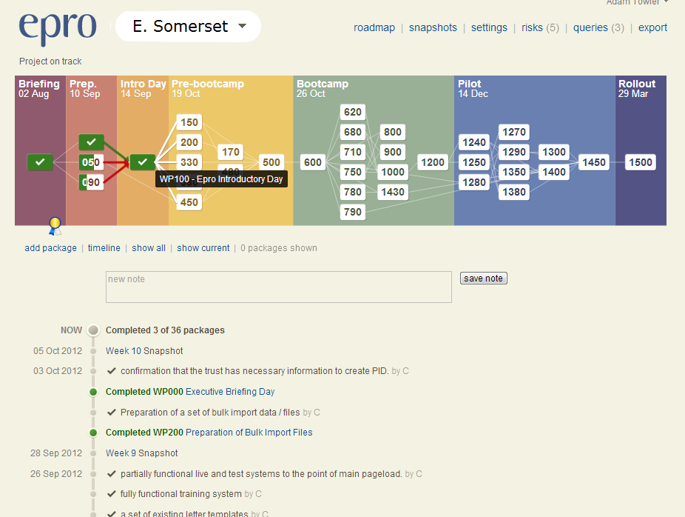
Illustration of a snapshot of a project showing completion of work packages, dependencies between them and the integrated timeline view.
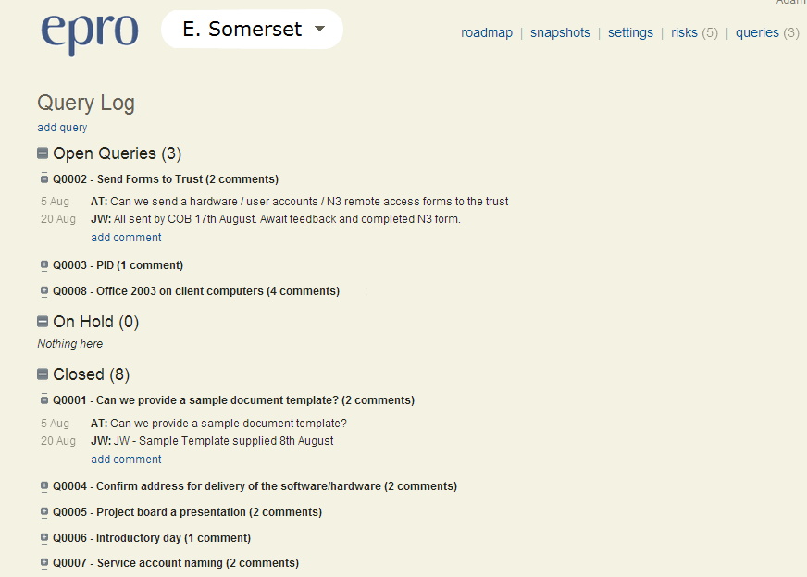
Example of the integrated query log designed to aid shared communication
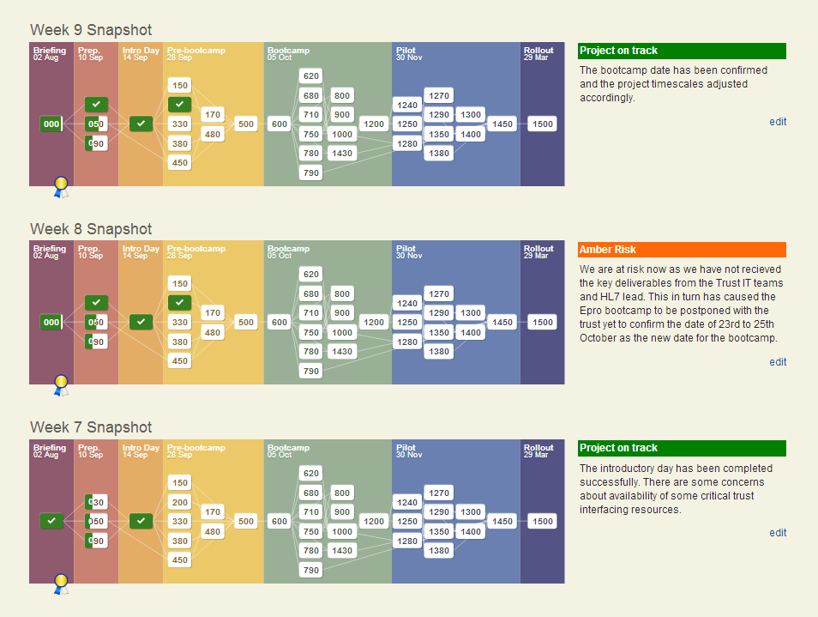
The progress of the project is captured as weekly snapshots which are also mailed to project team members.

Significant customised software development
The Epro development team is UK based, uses agile development techniques and is practised in the development of software to short timescales, with the necessary infra-structure to support that and a history of delivering successful customised development for trusts. It is not uncommon to receive additional development requests for new implementations; however it is strongly recommended that these should be accommodated as additional work after the initial pilot go live, otherwise there is a tendency to delay the implementation date and a risk of deviating from the critical path and core project objectives.

Project stages
The following section provides more detail on each of the seven key project stages, including the outputs (project assets) from each stage. More detail associated with each of the individual work packages together with responsibilities is included on the roadmap tool.

Stage 1 - Kickoff
This work package takes the form of telephone contact and onsite meeting(s) between the two project managers, Epro implementation lead and selected other team members soon after contract signature. The primary purposes are to establish relationships, to arrange the engagement day and distribute documents which explain the implementation methodology.
The technical planning call is recommended early in the process as a means of mitigation against possible delays arising from N3 / remote access, hardware availability and the demographics interface.

Epro Engagement Day
This day is an important element of the Kickoff stage, and is vital to future successful change management.
The day divides into different sections based around the core project team in the morning, drop in demonstration sessions over lunch, and further sessions as needed for the technical team, secretary super users and the project managers /executive sponsors during the afternoon.
We will revisit the objectives and scope of the project and fill any gaps in the assignment of project team members who will perform the key roles and responsibilities, and also set the provisional timescales for the remainder of the project.
At the end of the day, all team members should have a clear idea of the project objectives, an overview of the technologies involved, and a better understanding of the impact of the forthcoming project changes.

Principal activities
- Relationship building between teams
- Exploration of project implementation methodology / controls / governance
- Exploration of Epro solution
- Commissioning of remote access / server hardware
- Building of proof of concept servers (Epro team)
- Preparation of remote deployment packages for client software (trust team)

Principal assets
- Formal approval for work to begin obtained from trust sponsor
- Relationships
- A review of the implementation methodology with understanding of the full project life-cycle
- High level agreement of project methodology / communication management / controls
- Outline project timescale
- Identification of any critical dependencies (such as interfaces to external systems)
- An agreed list of project team members
- Specification for network accounts / hardware (provided by Epro team)
- Hardware commissioned with basic software installed and remote access available
- Proof of concept servers built
- Finalization of objectives, success criteria and PID (trust team)
- An end-to-end demonstration of the system
- Understanding of the basic letter creation and dictation workflow
- Understanding of the demographic data migration and interface requirements
- A review of the Epro Implementation Bootcamp tasks and the necessary inputs to this from the trust.
- Stage 1 sign off – Kickoff

Stage 2 - Preparation
Following the Epro discovery day there will be a number of implementation tasks that must be complete before the Epro boot camp can take place. The majority of these revolve around the bulk data migration, and preparation / testing of the HL7 interface.

Principal activities
- Preparation of a valid set of HL7 test messages (Trust team + Epro team to validate)
- Preparation of a set of bulk import files from the PAS (Trust team)
- Development of provisional Standard Operating Procedures (trust team)
- Provision of existing / proposed letter templates (trust team)
- Proof of concept connection of HL7 interface (Epro and trust teams)
- Loading of a bulk import of data from the trust’s PAS into the Epro system
- The Commissioning and connection of an HL7 (or other) interface with the PAS

Principal assets
- A functional and tested demographics interface
- Provisional trust Standard Operating Procedures / Development of a provisional “To be” process
- Copies of existing / proposed letter templates
- Remote deployment packages for client software
- Stage 2 sign off – preparation

Stage 3 - Epro Transcriber Bootcamp
During the Epro transcriber bootcamp, the Epro team will work onsite jointly with the trust team until the system is in live use for a small section (transcription) of the letter production process. Letters will continue to be dictated and approved on pre-existing systems, and the transcription element will occur in Epro.
The system will be configured to reflect Epro project team experience in implementations of this nature and there will be minimum customisation of the product other than local templates etc.
The intention is to get Epro up and running in one or more pilot areas so that the trust can learn from the experience and make informed decisions regarding the best way to implement /configure the system prior to wider roll out to non-pilot areas.
Three essential features of the boot camp are
- extended face to face contact time between the two teams
- hands on internal mini-pilots
- preliminary information governance and clinical risk assessments.

Internal mini-pilots
In these exercises, the members of the project team play the roles of the future users and rehearse the ‘to be’ processes as walk-throughs. This gives opportunities to gradually develop deeper understanding of the solution, and identify any problems with proposed workflow etc.

Principal activities
- The design and agreement of the pilot document letter templates
- A review of the basic Epro functionality
- Mini-pilots / acceptance testing internal to the project team.
- Training of users for a closely supervised initial pilot go-live
- Information governance assessment

Principal assets
- Functional live/test and training systems, tested to enable limited go live
- The achievement of the first live group of users
- Preliminary information governance assessment
- Stage 3 sign off

Stage 4 – Pre-pilot
The pre-pilot is a bedding in period in which the users trained in the Epro Transcriber Bootcamp become familiar with the solution. The Epro team visit weekly to assist with progress and make the necessary preparations for the Epro Transcriber Bootcamp

Principal activities
- Acquire gradually increasing familiarity with the solution
- Evaluate the templates
- Review of demographics interface
- Extend the use of the solution to additional transcribers within the pilot departments

Principal assets
- Group of transcribers familiar with the transcription element of the software
- Live letters being produced in the solution.
- Hardware checked and prepared for the Epro Author Bootcamp

Stage 5 – Epro Author Bootcamp
During the Epro Author Bootcamp, the progress to date is reviewed with the transcribers, prior to extending the use of the solution across the whole workflow by adding capture of dictations, electronic review / approval and issuing.

Principal activities
- Review of progress to date
- Extension to the whole letter production process
  - Capture of voice files
  - Uploading of voice files (where portable devices used)
  - Electronic review / approval
  - Issue process
  - Distribution to GPs (where appropriate)
- Planning of dictation workflow
- Clinical governance assessment

Principal assets
- Consolidation of transcription process
- Coverage of whole letter production process
- Representatives of the pilot departments using the system for live work
- Dictation workflow routing plan

Stage 6 - Pilot
After the Epro Author Bootcamp (which leaves some users in one or two pilot departments live with the end-to-end process), there is then a Pilot stage, the length of which is determined by the trust. This is the stage in which the trust team consolidates the changes to date, extends use to the remaining pilot department members and prepares to scale out the project.

Principal activities
- Acquire gradually increasing familiarity with the solution, moving towards a detailed understanding necessary to plan a rapid efficient roll out
- Review the fit to existing processes, and make or plan to make any necessary improvements to form the ‘to be’ processes which drive the change management for the roll out
- Develop the expertise of one or more super-user secretaries who will play an important part in the roll out
- Develop a training plan, which drives the train the trainer course
- Agree any changes to the software as a result of custom development
- Fix any defects which become apparent with a mop-up build prior to roll out
- Coalesce the above to a well-defined repeatable package which can be executed serially to multiple groups within the trust
- Develop a roll out plan determining the order of deployment of the package

Principal assets
- A clinical governance / risk assessment
- An information governance assessment
- Configuration of workflows / departments / users
- A training / roll out package
- A reporting plan / methodology
- Stage 6 sign off – pilot stage complete

Stage 7 - Roll out
The roll out process is largely managed by the trust implementation team. As a result of the pilot, there should now be a thorough understanding of the solution and a well-defined roll out package and plan.

Principal activities
The trust implementation team will progressively roll out the solution to users across the trust on a group by group basis.

Principal assets
- Roll out methodology
- Stage 7 sign off – roll out

Stage Sign off

Background
The Epro Implementation Methodology adopts the principle of stages from PRINCE II methodology. Each stage should be signed off by both parties, ideally before proceeding to subsequent stages. The responsibility for obtaining sign off is with the two project managers, although the project leads (where these are different people) will also need to indicate they are happy, usually by completing the work packages in the timeline tool. Sign off is recorded and managed in the Epro Roadmap tool. These events are then incorporated into the project timeline and weekly highlight reports.

Terms
Signatures (electronic or otherwise) to each stage acknowledges that the Trust has reviewed the products and services delivered by the Epro Implementation team and agrees the work to complete the project stage has been delivered. The Trust furthermore agrees that once all stages have been signed off this will indicate completion of the project and project signoff by the Trust, and the obligations outlined in the jointly agreed Project Initiation Document will have been met.

