Epro ITK Message Specification

Contents

Overview 1
Introduction 1
ITK HL7v3 Standards 1
Accreditations 1
Communication 1
ITK Specifications 1
Epro ITK Message Specifications 1
Overview 1
Payloads 2
Clinical Document XML Elements 2
ClinicalDocument Element 2
RecordTarget Element 5
Author Element 6
Custodian Element 7
InformationRecipient Element 8
ComponentOf Element 9
Component Element 10
Appendix 12
Sample Letter ITK Message 12

Overview
The purpose of this document is to explain the ITK messages produced by Epro for discharge summaries and letters.

Introduction

ITK HL7v3 Standards
Epro supports sending ITK HL7v3 Clinical Document Architecture messages. This includes the “Non-Coded CDA” and “Discharge” correspondence bundles, which relate to letters and discharge summaries in Epro respectively.

Accreditations
The messages sent by Epro comply with ITK 2.0.1 standards and have been accredited. The ITK accreditation document for Epro is available at http://www.bluewire-technologies.com/itk.

Communication
Epro offers a SOAP web service mechanism for sending discharge summary and letter (non-coded CDA) ITK messages.

ITK Specifications
Throughout this document, there will be references to the ITK specifications. These specifications are accessible through TRUD.

Epro ITK Message Specifications

Overview
A sample ITK message is illustrated below. ITK messages are XML documents, and when viewing them, we recommend using an XML viewer or a browser which allow individual nodes to be collapsed and expanded.
The illustration below shows the message with the two principal sections, header and payloads collapsed. The header section contains meta-information about the message, its protocols and content, and the payloads section contains one or more payloads in different formats.
Expanding the header and payloads section is illustrated below. The most useful element of the header is the manifest node, which describes the content of the payloads section.
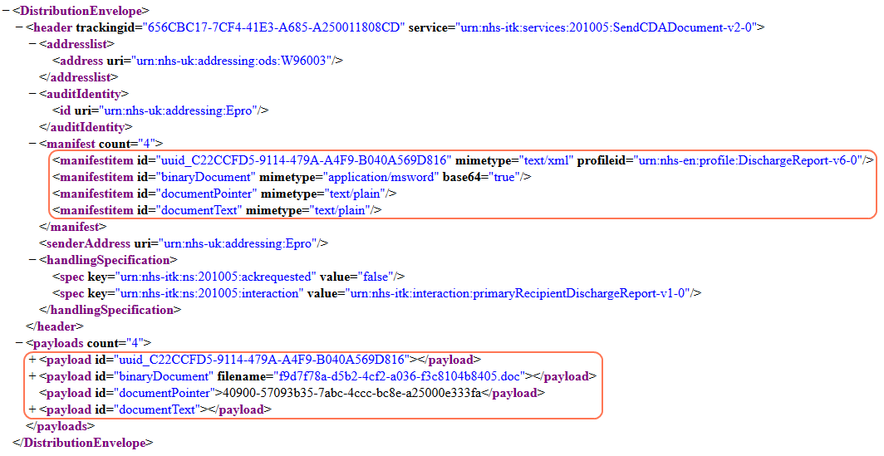MSG 1: Sample Discharge Clinical Document ITK message with the manifest and payload xml nodes highlighted.

Payloads
Generally the type of payloads carried by an ITK transmission will depend on the Service definition used. The Content Metadata Payload (seen above as the first payload) may be used by multiple Service definitions and is used to carry metadata about each payload in the transmission. There will only ever be one Content Metadata Payload. Not all payloads will attract metadata, but for payloads that do, the metadata is expressed in an IHE compliant format.
Epro can be configured to include one or more of several additional payloads as below.
Payload ID | Description
documentPointer | Provide an identifier for a document. Using this identifier, a URL can be constructed to give a static link directly to that document in Epro.
binaryDocument | Contains either a Microsoft Word or PDF document, depending on the configuration of Epro.
documentText | Contains a plain text representation of the correspondence document.

Clinical Document XML Elements

ClinicalDocument Element
The ClinicalDocument element is found within in the Content Metadata Payload and it contains the information describing the document (letter or Discharge Summary) in Epro alongside related event information (clinic appointments or patient discharge). Below is a sample ITK message showing this element.
The classCode and moodCode attributes at the root of this element allow the ClinicalDocument element to be identified both as a clinical document and as a document relating to an event respectively.
The typeId element is responsible for showing which CDA specification the document complies with. All the messages generated by Epro should have the same typeId as shown in the example below, where the root and extension attributes describe that the CDA document complies with CDA R2 specification.
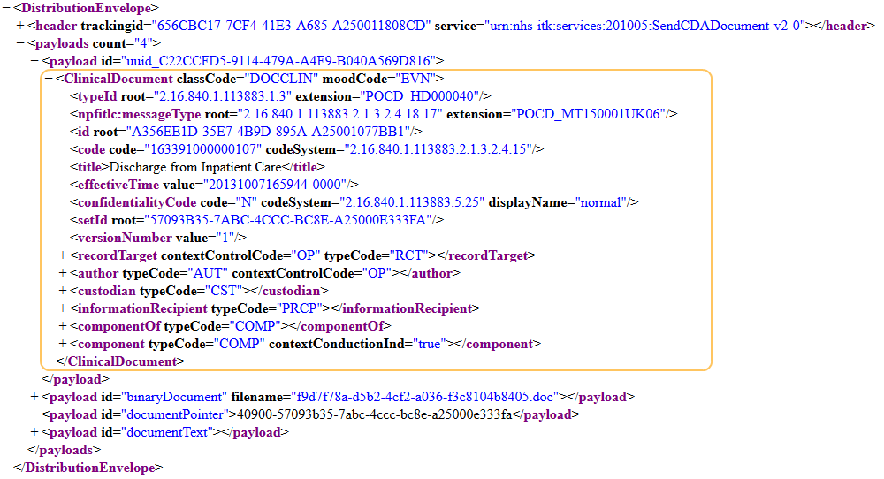
MSG 2: Sample Discharge Clinical Document ITK message with the clinical document element highlighted.
The code attribute and title element describe the type of clinical document and whether this document has been deleted in Epro (see table below).
Value of code | Value of title element | Type of document
163391000000107 | Discharge from Inpatient Care | Discharge Summary – associated with a patient admission.
163381000000105 | Patient Letter | Letter – often relates to outpatient clinic appointment.
285091000000108 | N/A | Deleted Document – includes letters and Discharge Summaries.
The date the ITK message is generated is described in the effectiveTime element.
To identify whether restricted access has been applied to the document in Epro, the confidentialityCode element is used. Documents will default to having normal confidentiality level (code=”N” displayName=”normal”), whereas restricted documents with have the restricted confidentially level (code=”R” displayName=”restricted”).
The recordTarget element describes the patient who is the target for the information within this document. This element contains patient name, address and their (local / national) identifiers.
The author element contains information describing the individual who wrote this document. This includes document creation date, author name, identifiers, address and the sending organisation.
The custodian element represents the organisation that is the owner of the document.
The informationRecipient element describes the intended recipient of the document (typically a GP), which includes person name, identifiers and the receiving organisation.
The componentOf element contains the associated event with the document. For letters, this contains information associated with clinic appointments. For discharge summaries, this contains information regarding the patient admission and discharge.
The component element may contain a document body that will have one or more message bodies. This may contain binary (Microsoft Word, PDF) or HTML message body.
The id, setId and versionNumber attributes are used to identify documents across multiple ITK messages. When this document changes in Epro, the ITK message generated with keep the original setId value, yet versionNumber changes accordingly. Each document will have a unique id value, regardless of whether they belong to the same set of historical documents.
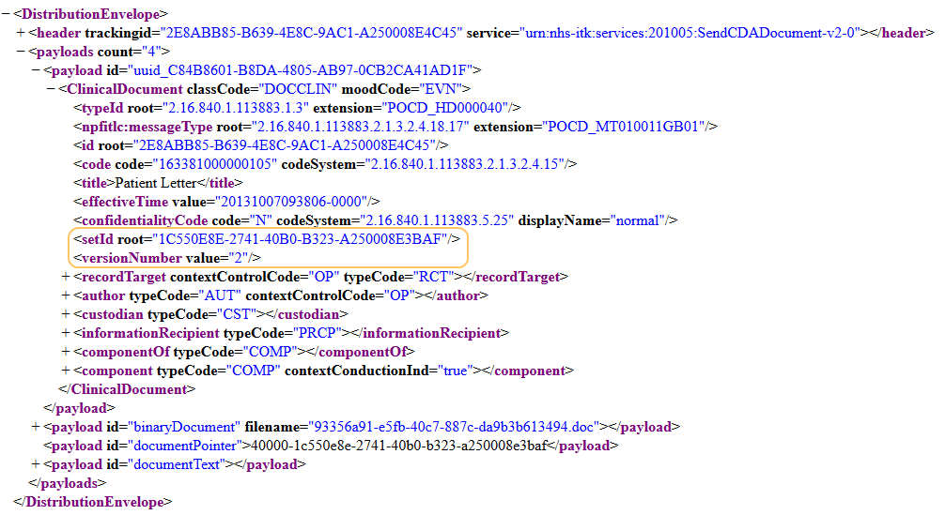
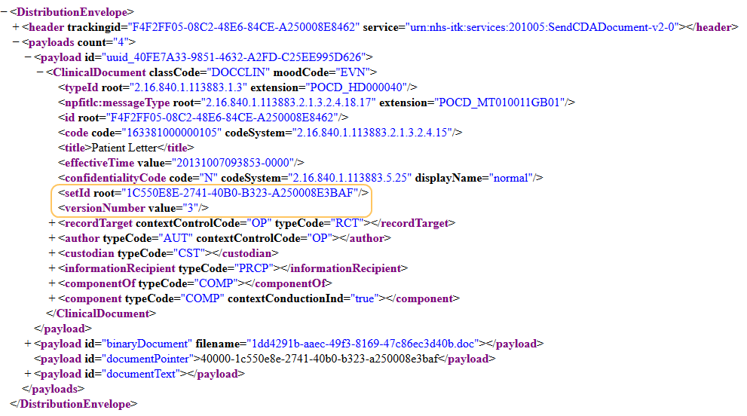
MSG 3: Two separate messages that refer to the same document.

RecordTarget Element
The patient element contains the patient’s name, gender and date of birth (see ITK message below). The address of the patient can be found within the addr element.
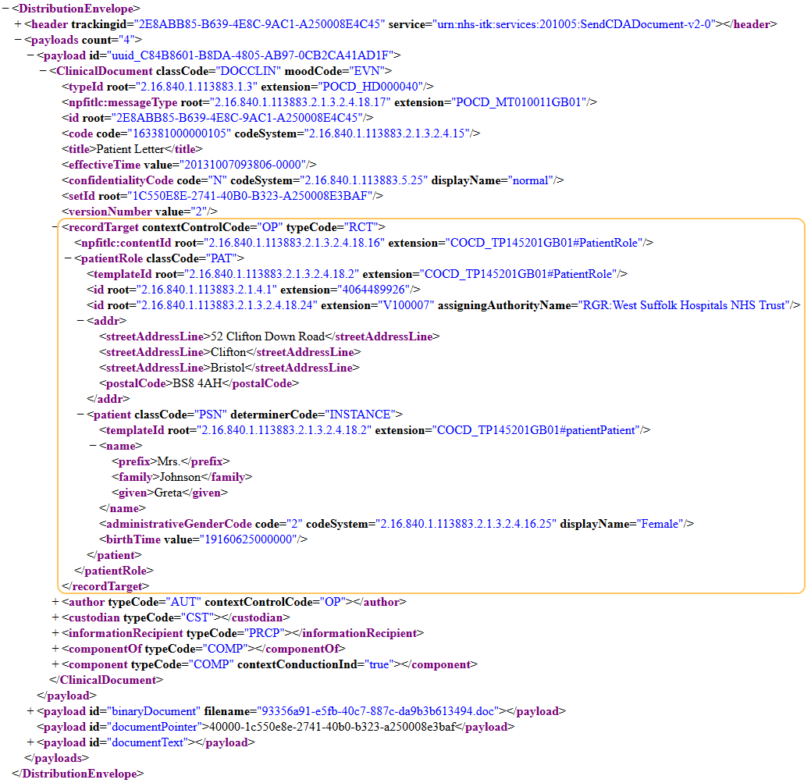
MSG 4: ITK message with the recordTarget element highlighted.
The patient identifiers are found in the id elements (within the patientRole element). The table below shows the mapping between the root attribute and the extension attribute.
Value of root attribute | Description of extension attribute
2.16.840.1.113883.2.1.4.1 | NHS Number present and verified.
2.16.840.1.113883.2.1.3.2.4.18.23 | NHS Number present but unverified.
2.16.840.1.113883.2.1.3.2.4.18.24 | Trust local patient identifier.

Author Element
In the sample message below, there is the author element highlighted. In this message functionCode element describes the author as the originating author, which maps to the author of the document in Epro.
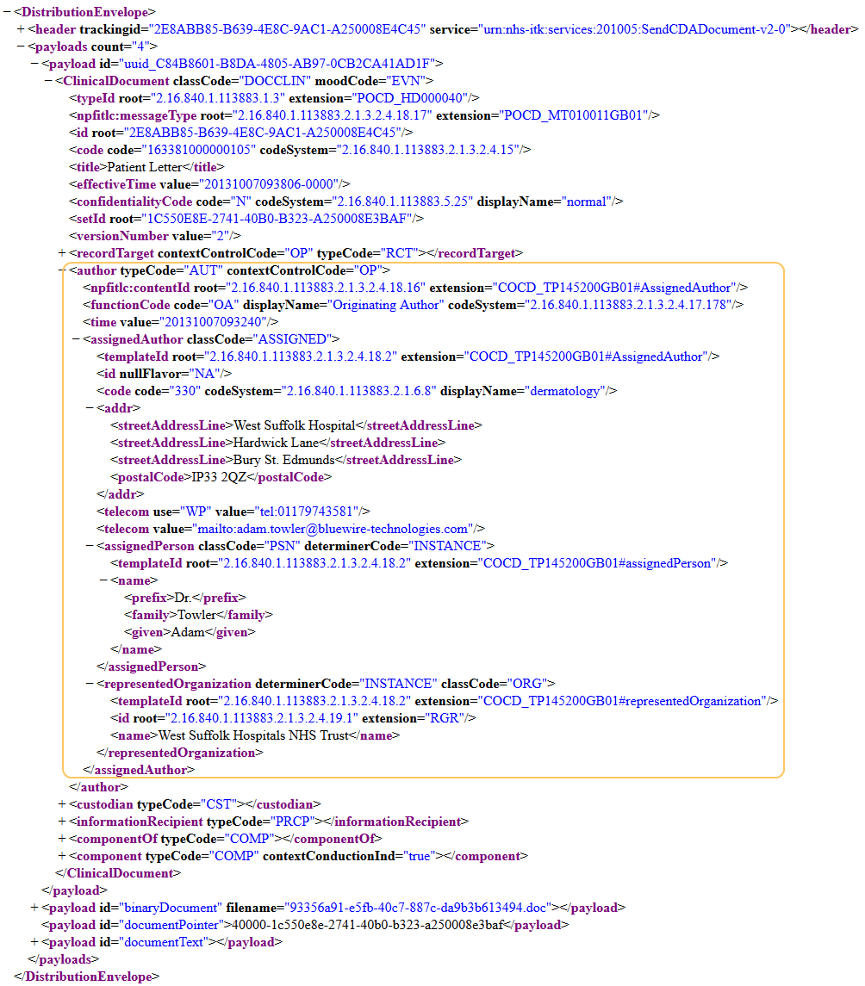
MSG 5: ITK message with the author element highlighted.
The time element describes the date and time the document was first created in Epro.
The information regarding the specialties associated with a document are stored alongside the author in the code element. Epro uses the NHS Data Dictionary Specialties coding system (“2.16.840.1.113883.2.1.6.8”) for specialties (see http://www.datadictionary.nhs.uk/version3/data_dictionary/attributes/t/tran/treatment_function_code_de.asp).
The id element contains the identifier of the author. If the author is a GP or consultant, then the extension attribute will contain their national code. The value of the code attribute indicates whether the author is a GP or consultant. If the national code represents a GP, the code attribute will contain 2.16.840.1.113883.2.1.4.2. For consultants, it will contain 2.16.840.1.113883.2.1.4.4. If the author’s national code is not known, the id element will contain the attribute nullFlavor=”NA”. Should the author not be a GP or consultant, then the attribute nullFlavor=”NI” will be used instead.
The telecom elements contain the telephone numbers and email address associated with the author. The use attribute may be present, see table below:
Value of use attribute | Description
HP | Home telephone number.
MC | Mobile telephone number.
WP | Work telephone number.
 | When absent, the value may contain a fax or email address.
The representedOrganization element describes the organisation associated with the author. The id element within this contains their organisation code.

Custodian Element
The custodian element primarily contains the representedOrganization attribute which was discussed above.
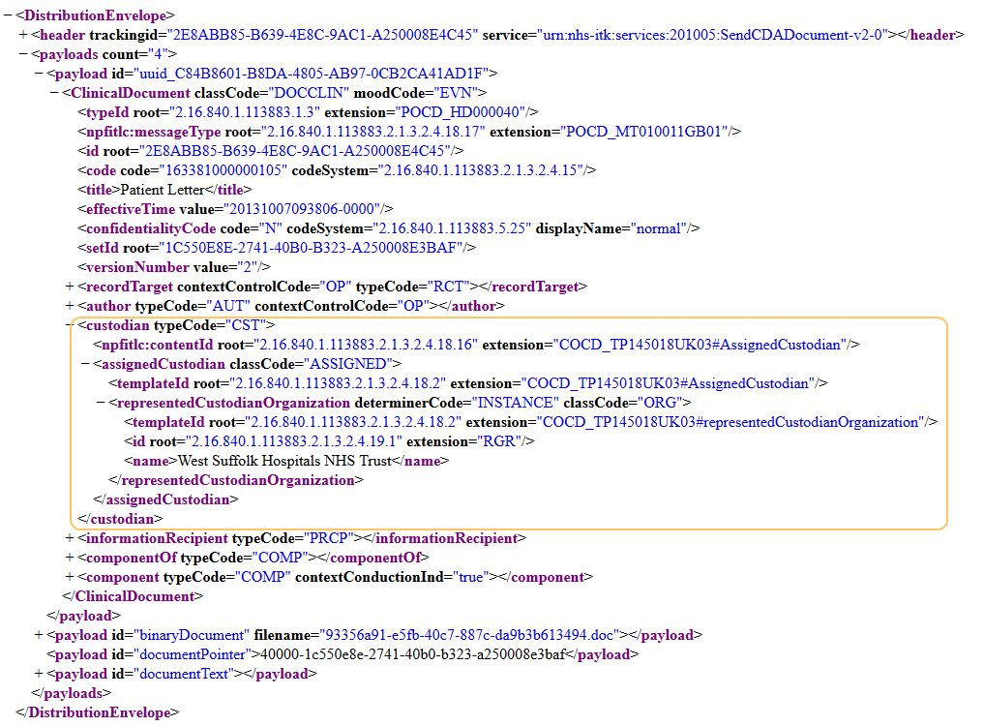
MSG 6: ITK message with the custodian element highlighted.

InformationRecipient Element
The intended recipient of the document is the patient’s GP for discharge summaries or the letter recipient for letters. The child elements for the informationRecipient element (see illustration below), are similar to those of the author element discussed in a previous section.
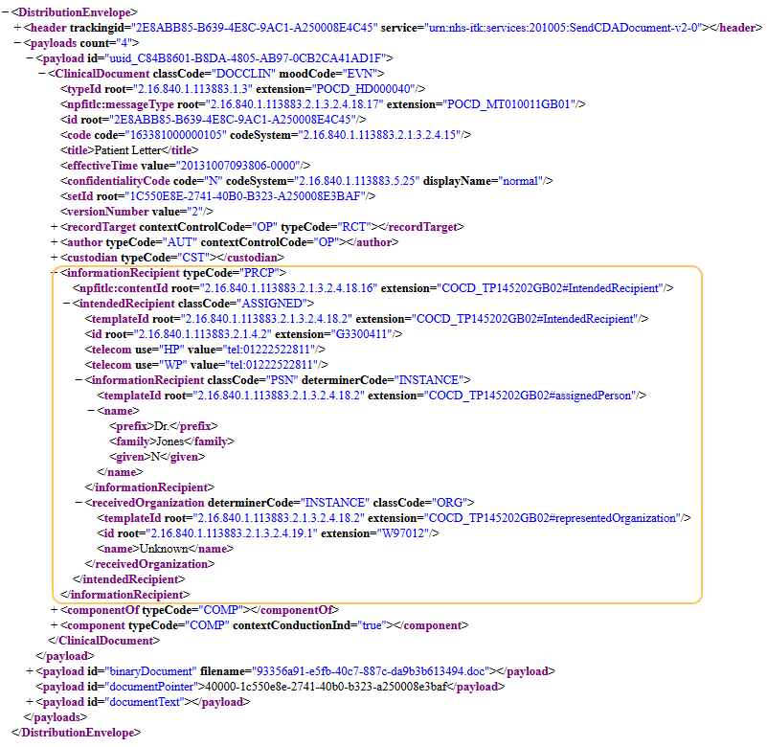
MSG 7: ITK message with informationRecipient element highlighted.

ComponentOf Element
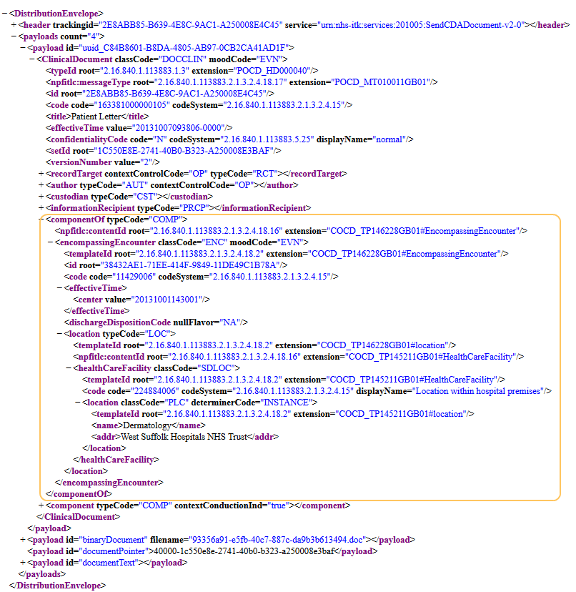
MSG 8: ITK message with componentOf element highlighted.
The code element contains the external Id of the clinic appointment or patient admission, when this data is present in Epro.
Value of codeSystem attribute | Description of value in code attribute
2.16.840.1.113883.2.1.3.2.4.15 | Equals 11429006, which is the SNOMED CT Consultation code. Present when no external Id can be associated.
2.16.840.1.113883.2.1.3.2.4.17.413 | External ID of the clinic appointment or patient admission.

The information regarding the department of the document is stored in the location element (within the healthCareFacility element).
For discharge summaries, the effectiveTime element describes the date and time the summary was created. For letters, the effectiveTime has several meanings depending on the context of the letter. Whenever possible, it will be set to the clinic date form field on the letter. If this is data is not available and this document has been associated with a clinic appointment in Epro, the date of the clinic appointment is used. When this data is also not present, it contains the date and time the document was created – see screenshot.
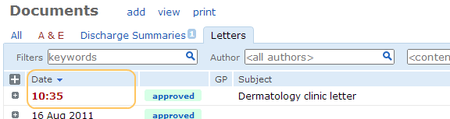
IMG 1: Screenshot from Epro showing date created field of a letter.

Component Element
Epro supports storing documents (Word / PDF) inside the ClinicalDocument payload. This is the recommended location, rather than using the separate binaryDocument payload discussed above.
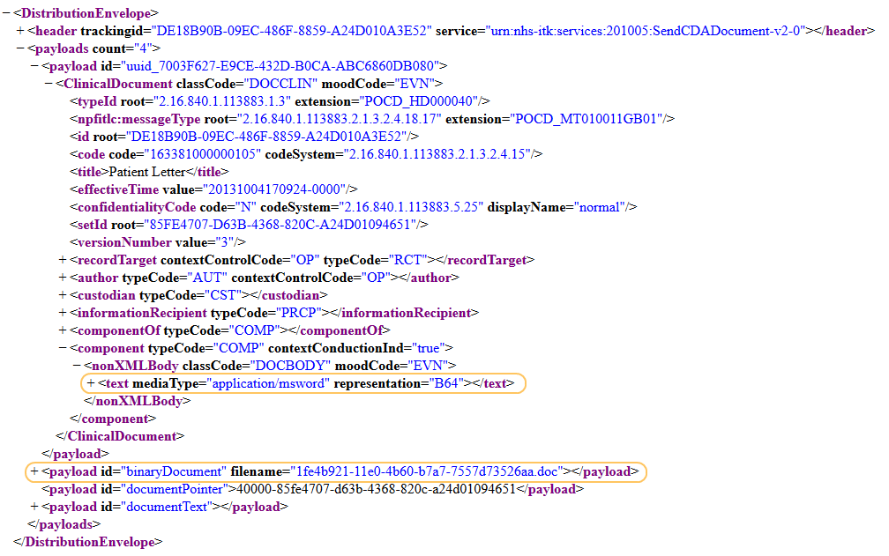
MSG 9: ITK message with “binaryDocument” payload and Word Document element highlighted.
The ClinicalDocument payload can be generated in Epro to include a HTML representation of the document. If this configured in Epro, then documents (Word / PDF) cannot be generated inside the ClinicalDocument payload.
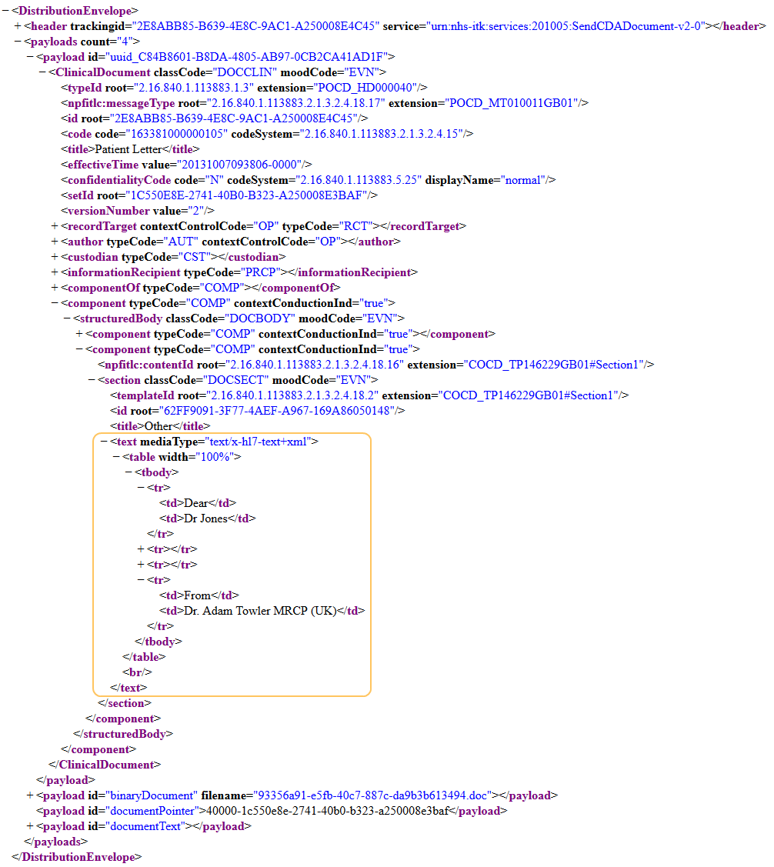
MSG 10: ITK message with a section of HTML text highlighted.

Appendix

Sample Letter ITK Message

<?xml version="1.0" encoding="utf-8"?>
<DistributionEnvelope xmlns:xsd="http://www.w3.org/2001/XMLSchema" xmlns:xsi="http://www.w3.org/2001/XMLSchema-instance" xmlns="urn:nhs-itk:ns:201005">
<header trackingid="F5E8B4BD-B06B-4C60-B79C-A24C00B1317F" service="urn:nhs-itk:services:201005:SendCDADocument-v2-0">
<addresslist>
<address uri="urn:nhs-uk:addressing:ods:Y01212" />
</addresslist>
<auditIdentity>
<id uri="urn:nhs-uk:addressing:Epro" />
</auditIdentity>
<manifest count="4">
<manifestitem id="uuid_1C0F2B4A-0171-4908-81FE-42138D48EF2A" mimetype="text/xml" profileid="urn:nhs-en:profile:nonCodedCDADocument-v2-0" />
<manifestitem id="binaryDocument" mimetype="application/msword" base64="true" />
<manifestitem id="documentPointer" mimetype="text/plain" />
<manifestitem id="documentText" mimetype="text/plain" />
</manifest>
<senderAddress uri="urn:nhs-uk:addressing:Epro" />
<handlingSpecification>
<spec key="urn:nhs-itk:ns:201005:ackrequested" value="false" />
<spec key="urn:nhs-itk:ns:201005:interaction" value="urn:nhs-itk:interaction:primaryRecipientNonCodedCDADocument-v2-0" />
</handlingSpecification>
</header>
<payloads count="4">
<payload id="uuid_1C0F2B4A-0171-4908-81FE-42138D48EF2A">
<ClinicalDocument classCode="DOCCLIN" moodCode="EVN" xmlns:npfitlc="NPFIT:HL7:Localisation" xmlns:xsi="http://www.w3.org/2001/XMLSchema-instance" xmlns="urn:hl7-org:v3">
<typeId root="2.16.840.1.113883.1.3" extension="POCD_HD000040" />
<npfitlc:messageType root="2.16.840.1.113883.2.1.3.2.4.18.17" extension="POCD_MT010011GB01" />
<id root="F5E8B4BD-B06B-4C60-B79C-A24C00B1317F" />
<code code="163381000000105" codeSystem="2.16.840.1.113883.2.1.3.2.4.15" />
<title>Patient Letter</title>
<effectiveTime value="20131003114509-0000" />
<confidentialityCode code="N" codeSystem="2.16.840.1.113883.5.25" displayName="normal" />
<setId root="7E36368F-D6CE-4630-945A-A24C00B125F5" />
<versionNumber value="2" />
<recordTarget contextControlCode="OP" typeCode="RCT">
<npfitlc:contentId root="2.16.840.1.113883.2.1.3.2.4.18.16" extension="COCD_TP145201GB01#PatientRole" />
<patientRole classCode="PAT">
<templateId root="2.16.840.1.113883.2.1.3.2.4.18.2" extension="COCD_TP145201GB01#PatientRole" />
<id root="2.16.840.1.113883.2.1.3.2.4.18.23" extension="5588326350" />
<id root="2.16.840.1.113883.2.1.3.2.4.18.24" extension="X890789" assigningAuthorityName="RGR:West Suffolk Hospitals NHS Trust" />
<addr>
<streetAddressLine>Clifton College</streetAddressLine>
<streetAddressLine>83 Pembroke Road</streetAddressLine>
<streetAddressLine>Clifton</streetAddressLine>
<streetAddressLine>Bristol</streetAddressLine>
<postalCode>BS8 3EA</postalCode>
</addr>
<patient classCode="PSN" determinerCode="INSTANCE">
<templateId root="2.16.840.1.113883.2.1.3.2.4.18.2" extension="COCD_TP145201GB01#patientPatient" />
<name>
<prefix>Miss</prefix>
<family>Hardwick</family>
<given>Emily</given>
</name>
<administrativeGenderCode code="2" codeSystem="2.16.840.1.113883.2.1.3.2.4.16.25" displayName="Female" />
<birthTime value="20080617145229" />
</patient>
</patientRole>
</recordTarget>
<author typeCode="AUT" contextControlCode="OP">
<npfitlc:contentId root="2.16.840.1.113883.2.1.3.2.4.18.16" extension="COCD_TP145200GB01#AssignedAuthor" />
<functionCode code="OA" displayName="Originating Author" codeSystem="2.16.840.1.113883.2.1.3.2.4.17.178" />
<time value="20131003114438" />
<assignedAuthor classCode="ASSIGNED">
<templateId root="2.16.840.1.113883.2.1.3.2.4.18.2" extension="COCD_TP145200GB01#AssignedAuthor" />
<id nullFlavor="NI" />
<code code="320" codeSystem="2.16.840.1.113883.2.1.6.8" displayName="cardiology" />
<addr>
<streetAddressLine>35 Caledonia Place</streetAddressLine>
<streetAddressLine>Bristol</streetAddressLine>
<postalCode>BS8 4DN</postalCode>
</addr>
<telecom use="WP" value="tel:01179743581" />
<telecom value="mailto:benjamin.arroyo@bluewire-technologies.co" />
<assignedPerson classCode="PSN" determinerCode="INSTANCE">
<templateId root="2.16.840.1.113883.2.1.3.2.4.18.2" extension="COCD_TP145200GB01#assignedPerson" />
<name>
<prefix>Mr.</prefix>
<family>Arroyo</family>
<given>Benjamin</given>
</name>
</assignedPerson>
<representedOrganization determinerCode="INSTANCE" classCode="ORG">
<templateId root="2.16.840.1.113883.2.1.3.2.4.18.2" extension="COCD_TP145200GB01#representedOrganization" />
<id root="2.16.840.1.113883.2.1.3.2.4.19.1" extension="RGR" />
<name>West Suffolk Hospitals NHS Trust</name>
</representedOrganization>
</assignedAuthor>
</author>
<custodian typeCode="CST">
<npfitlc:contentId root="2.16.840.1.113883.2.1.3.2.4.18.16" extension="COCD_TP145018UK03#AssignedCustodian" />
<assignedCustodian classCode="ASSIGNED">
<templateId root="2.16.840.1.113883.2.1.3.2.4.18.2" extension="COCD_TP145018UK03#AssignedCustodian" />
<representedCustodianOrganization determinerCode="INSTANCE" classCode="ORG">
<templateId root="2.16.840.1.113883.2.1.3.2.4.18.2" extension="COCD_TP145018UK03#representedCustodianOrganization" />
<id root="2.16.840.1.113883.2.1.3.2.4.19.1" extension="RGR" />
<name>West Suffolk Hospitals NHS Trust</name>
</representedCustodianOrganization>
</assignedCustodian>
</custodian>
<informationRecipient typeCode="PRCP">
<npfitlc:contentId root="2.16.840.1.113883.2.1.3.2.4.18.16" extension="COCD_TP145202GB02#IntendedRecipient" />
<intendedRecipient classCode="ASSIGNED">
<templateId root="2.16.840.1.113883.2.1.3.2.4.18.2" extension="COCD_TP145202GB02#IntendedRecipient" />
<id root="2.16.840.1.113883.2.1.4.2" extension="G6664921" />
<addr>
<streetAddressLine>22 The Avenue</streetAddressLine>
<streetAddressLine>Clifton</streetAddressLine>
<streetAddressLine>York</streetAddressLine>
<postalCode>YO30 6AS</postalCode>
</addr>
<telecom use="HP" value="tel:01904553170" />
<telecom use="WP" value="tel:01904553170" />
<informationRecipient classCode="PSN" determinerCode="INSTANCE">
<templateId root="2.16.840.1.113883.2.1.3.2.4.18.2" extension="COCD_TP145202GB02#assignedPerson" />
<name>
<prefix>Dr.</prefix>
<family>Assertive Outreach Team</family>
<given>
</given>
</name>
</informationRecipient>
<receivedOrganization determinerCode="INSTANCE" classCode="ORG">
<templateId root="2.16.840.1.113883.2.1.3.2.4.18.2" extension="COCD_TP145202GB02#representedOrganization" />
<id root="2.16.840.1.113883.2.1.3.2.4.19.1" extension="Y01212" />
<name>Assertive Outreach Team</name>
</receivedOrganization>
</intendedRecipient>
</informationRecipient>
<componentOf typeCode="COMP">
<npfitlc:contentId root="2.16.840.1.113883.2.1.3.2.4.18.16" extension="COCD_TP146228GB01#EncompassingEncounter" />
<encompassingEncounter classCode="ENC" moodCode="EVN">
<templateId root="2.16.840.1.113883.2.1.3.2.4.18.2" extension="COCD_TP146228GB01#EncompassingEncounter" />
<id root="0A9232C4-448E-453B-B544-61207173ED74" />
<code code="11429006" codeSystem="2.16.840.1.113883.2.1.3.2.4.15" />
<effectiveTime>
<center value="20100210115704" />
</effectiveTime>
<dischargeDispositionCode nullFlavor="NA" />
<location typeCode="LOC">
<templateId root="2.16.840.1.113883.2.1.3.2.4.18.2" extension="COCD_TP146228GB01#location" />
<npfitlc:contentId root="2.16.840.1.113883.2.1.3.2.4.18.16" extension="COCD_TP145211GB01#HealthCareFacility" />
<healthCareFacility classCode="SDLOC">
<templateId root="2.16.840.1.113883.2.1.3.2.4.18.2" extension="COCD_TP145211GB01#HealthCareFacility" />
<code code="224884006" codeSystem="2.16.840.1.113883.2.1.3.2.4.15" displayName="Location within hospital premises" />
<location classCode="PLC" determinerCode="INSTANCE">
<templateId root="2.16.840.1.113883.2.1.3.2.4.18.2" extension="COCD_TP145211GB01#location" />
<name>Dermatology</name>
<addr>West Suffolk Hospitals NHS Trust</addr>
</location>
</healthCareFacility>
</location>
</encompassingEncounter>
</componentOf> <component typeCode="COMP" contextConductionInd="true">
<structuredBody classCode="DOCBODY" moodCode="EVN">
<component typeCode="COMP" contextConductionInd="true">
<section classCode="DOCSECT" moodCode="EVN">
<id root="AA2FB44D-4F62-453E-8BAF-E50FB90B0843" />
<component typeCode="COMP" contextConductionInd="true">
<npfitlc:contentId root="2.16.840.1.113883.2.1.3.2.4.18.16" extension="COCD_TP146229GB01#Section1" />
<section classCode="DOCSECT" moodCode="EVN">
<templateId root="2.16.840.1.113883.2.1.3.2.4.18.2" extension="COCD_TP146229GB01#Section1" />
<id root="977C213C-F039-4BE6-874D-797F69884304" />
<title>GP Details</title>
<text mediaType="text/x-hl7-text+xml">
<table width="100%">
<tbody>
<tr>
<td>GP Name</td>
<td>
<content styleCode="Bold">Assertive Outreach Team, (Dr)</content>
</td>
</tr>
<tr>
<td>GP Practice Address</td>
<td>
<content styleCode="Bold">22 The Avenue, Clifton, York, YO30 6AS</content>
</td>
</tr>
</tbody>
</table>
<br />
</text>
</section>
</component>
<component typeCode="COMP" contextConductionInd="true">
<npfitlc:contentId root="2.16.840.1.113883.2.1.3.2.4.18.16" extension="COCD_TP146229GB01#Section1" />
<section classCode="DOCSECT" moodCode="EVN">
<templateId root="2.16.840.1.113883.2.1.3.2.4.18.2" extension="COCD_TP146229GB01#Section1" />
<id root="E0C72EF9-C4B9-4DBF-A5C2-2E07757DAE50" />
<title>Patient personal data</title>
<text mediaType="text/x-hl7-text+xml">
<table width="100%">
<tbody>
<tr>
<td>Patient's name</td>
<td>
<content styleCode="Bold">HARDWICK, Emily (Miss)</content>
</td>
</tr>
<tr>
<td>Known As</td>
<td>
<content styleCode="Bold">
</content>
</td>
</tr>
<tr>
<td>Date of Birth</td>
<td>
<content styleCode="Bold">17-Jun-2008</content>
</td>
</tr>
<tr>
<td>Gender</td>
<td>
<content styleCode="Bold">Female</content>
</td>
</tr>
<tr>
<td>Local identifier</td>
<td>
<content styleCode="Bold">X890789</content>
</td>
</tr>
<tr>
<td>Address</td>
<td>
<content styleCode="Bold">Clifton College, 83 Pembroke Road, Clifton, Bristol, BS8 3EA</content>
</td>
</tr>
<tr>
<td>Patient's Telephone Number</td>
<td>
<content styleCode="Bold">
</content>
</td>
</tr>
</tbody>
</table>
<br />
</text>
</section>
</component>
</section>
</component>
<component typeCode="COMP" contextConductionInd="true">
<npfitlc:contentId root="2.16.840.1.113883.2.1.3.2.4.18.16" extension="COCD_TP146229GB01#Section1" />
<section classCode="DOCSECT" moodCode="EVN">
<templateId root="2.16.840.1.113883.2.1.3.2.4.18.2" extension="COCD_TP146229GB01#Section1" />
<id root="09C3D8FB-30F8-4753-BD29-722E20689D2B" />
<title>Other</title>
<text mediaType="text/x-hl7-text+xml">
<table width="100%">
<tbody>
<tr>
<td>Dear</td>
<td>Dr Assertive Outreach Team</td>
</tr>
<tr>
<td>Clinic date</td>
<td>10 Feb 2010</td>
</tr>
<tr>
<td>
</td>
<td>
<content>This patient did not attend.</content>
</td>
</tr>
<tr>
<td>From</td>
<td>Mr. B. Arroyo</td>
</tr>
</tbody>
</table>
<br />
</text>
</section>
</component>
</structuredBody>
</component>
</ClinicalDocument> </payload>
<payload id="binaryDocument" filename="654dacfb-c3d6-493a-82a0-9ac85aebb2e0.doc">0M8R4KGxGuEAAAAA
...w==</payload>
<payload id="documentPointer">40000-7e36368f-d6ce-4630-945a-a24c00b125f5</payload>
<payload id="documentText"> Dept of Dermatology

Dr Assertive Outreach Team
22 The Avenue
Clifton
York
YO30 6AS Hardwick Lane
Bury St Edmunds
Suffolk
IP33 2QZ

Email: benjamin.arroyo@bluewire-technologies.co
Phone: (0117) 974 3581
Fax:
Website: www.wsh.nhs.uk
Clinic date: 10 Feb 2010

Typed: Patient CRN: X890789
Typed by: NHS number: 558 832 6350
Dictated Date:

Dear Dr Assertive Outreach Team

Miss Emily HARDWICK - 17 Jun 2008
Clifton College, 83 Pembroke Road, Clifton, Bristol, BS8 3EA

This patient did not attend.

Yours sincerely

Electronically signed by Mr. B. Arroyo</payload>
</payloads>
</DistributionEnvelope>

